Ten Mile Time Trial
Sunday, 5th June 2022, Start 7.30am
Course H10/8
Result Sheet
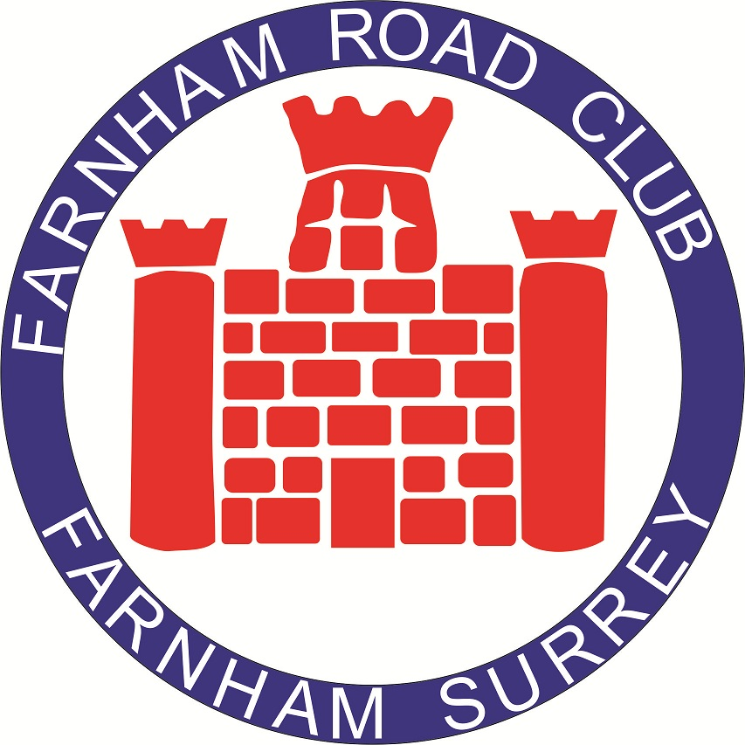

Event Headquarters
Farnham Town Football Club  Mead Lane  Farnham  Surrey  GU9 7DY | The entrance to the Football Club down Mead Lane is very narrow so please take care. Parking is also available at the Farnham Memorial Hall and you can walk through the footpath to and from the Football Club (it only takes two minutes).  The Farnham Town FC are providing refreshments so please support them.

Time Keepers | Event Secretary
Jim Brown, Farnham RC  Nigel Bicknell Alton CC | Paul Charman - Mobile 07725 825970  Home 01420 475709  E mail charmanpaul@hotmail.com
Thank you to all of those who helped me this year including timekeepers Jim Brown, Nigel Bicknell marshals Ian White, Stan Bennett, Greg Harding, Stuart Ayton, Mike Fricker, Harriet Somers, and Roger Taylor.
Thank you all for entering and riding on what was an unpromising morning. As it turned out the riding conditions were quite good if a little cold for June! Very many congratulations to the winners who I will be contacting by e mail to arrange for their awards to be paid.
I hope to see some of you in our next open event the team time trial on 17th July. Of course, we also organise club events every Tuesday evening on the H10/8 so if you were disappointed with your time come out and have another go. Entry fee £5. See our web site farnhamroadclub.co.uk for details.
Paul Charman

Awards
Category | 1st | 2nd | 3rd
Men | 18 | 15 | 12
Women | 18 | 15 | 12
Juvenile / Junior | 18 | 15 | 12
Fastest Vet 40-49 | 13
Fastest Vet 50-59 | 13
Fastest Vet 60-69 | 13
Fastest Vet 70-79 | 13
Fastest Vet 80-99 | 13

Men - Fastest

 | Riders | Club | Time | Prize
1st | Christopher McNamara | Nuun-Sigma Sport London | 00:19:49 | £18
2nd | Alex Franks | VC de Londres | 00:20:20 | £15
3rd | Joe Parker | Racing Club Ravenna | 00:20:32 | £12

Women - Fastest

 | Riders | Club | Time | Prize
1st | Michelle Lock | GS Stella | 00:28:26 | £18
2nd | Danielle Millar | Velo Club Godalming & Haslemere | 00:32:45 | £15

Fastest Juvenile, Junior, Espoir

 | Riders | Club | Time | Prize
1st | Alex Franks | VC de Londres | 00:20:20 | £18
Fastest Age Category 40-49

 | Riders | Club | Time | Prize
1st | Christopher McNamara | Nuun-Sigma Sport London | 00:19:49 | £13
Fastest Age Category 50-59

 | Riders | Club | Time | Prize
1st | Alan Murchison | WattShop | 00:20:50 | £13
Fastest Age Category 60-69

 | Riders | Club | Time | Prize
1st | Mike Anderson | CC Moncontour | 00:23:59 | £13
Fastest Age Category 70-79

 | Riders | Club | Time | Prize
1st | Richard Williams | Farnham Road Club | 00:26:19 | £13

